Addagalla Sahith Instagram user analytics

Project description:  
Instagram user analytics help to take insights like user experience, most used feature, what kind of changes need to be done for app development and so on

Approach:

Here I have used SQL for analysis, PostgreSQL is the tool which I have used for analysis

A) Marketing Analysis:

1. **Loyal User Reward:** The marketing team wants to reward the most loyal users, i.e., those who have been using the platform for the longest time.  
   Your Task: Identify the five oldest users on Instagram from the provided database.

SQL Query:

select *from users order by created_at ASC limit 5;

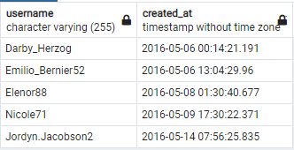

1. **Inactive User Engagement:** The team wants to encourage inactive users to start posting by sending them promotional emails.  
   Your Task: Identify users who have never posted a single photo on Instagram.

SQL Query:

SELECT username FROM users LEFT JOIN photos ON users.id = photos.user_id

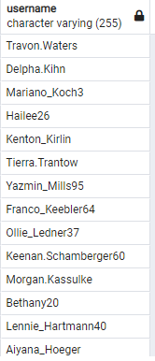

1. **Contest Winner Declaration:** The team has organized a contest where the user with the most likes on a single photo wins.  
   Your Task: Determine the winner of the contest and provide their details to the team.

SQL Query:

SELECT id,username FROM users WHERE id = (SELECT user_id

FROM photos WHERE id = (SELECT photo_id FROM likes

GROUP BY photo_id

ORDER BY Count(photo_id) DESC

LIMIT 1));

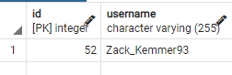

1. **Hashtag Research:** A partner brand wants to know the most popular hashtags to use in their posts to reach the most people.  
   Your Task: Identify and suggest the top five most commonly used hashtags on the platform.

SQL Query:

SELECT tags.tag_name,COUNT(*) AS total FROM photo_tags join tags ON photo_tags.tag_id = tags.id GROUP BY tags.id ORDER BY total DESC LIMIT 5;

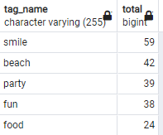

1. **Ad Campaign Launch:** The team wants to know the best day of the week to launch ads.  
   Your Task: Determine the day of the week when most users register on Instagram. Provide insights on when to schedule an ad campaign.

SQL:

SELECT to_char(created_at, 'DAY') "day of week",

Count(to_char(created_at, 'DAY')) "count of users registered"

FROM users

GROUP BY to_char(created_at,'DAY')

ORDER BY Count(to_char(created_at,'DAY')) DESC

LIMIT 2;

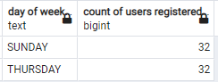

**B) Investor Metrics:**

1. **User Engagement:** Investors want to know if users are still active and posting on Instagram or if they are making fewer posts.  
   Your Task: Calculate the average number of posts per user on Instagram. Also, provide the total number of photos on Instagram divided by the total number of users.

SQL:

SELECT (SELECT Count(id)

FROM photos) / (SELECT Count(DISTINCT user_id)

FROM photos) AS Average_posts_per_User,

(SELECT Count(id)

FROM photos) / (SELECT Count(id)

FROM users) AS Ratio_of_Total_Posts_to_Total_Users;

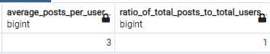

1. **Bots & Fake Accounts:** Investors want to know if the platform is crowded with fake and dummy accounts.  
   Your Task: Identify users (potential bots) who have liked every single photo on the site, as this is not typically possible for a normal user.

SQL:

SELECT id,

username

FROM users

WHERE id IN (SELECT user_id

FROM likes

GROUP BY user_id

HAVING Count(user_id) = (SELECT Count(id)

FROM photos));

